A report on

UNIFIED PAYMENT INTERFACE (UPI)

Submitted by

MIHIR SOLANKI :20BCS131,

MAYANK INGALE :20BCS127,

MERAVATH PAVAN KUMAR :20BCS130,

**Branch, year**

COMPUTER SCIENCE AND ENGINEERING, 2020

Submitted to

**Prof. Pritee Khanna**



PDPM INDIAN INSTITUTE OF INFORMATION TECHNOLOGY, DESIGN AND

MANUFACTURING JABALPUR, INDIA

November 16th , 2021

1. INTRODUCTION:

A Unified Payment Interface (UPI) is a smartphone application that allows users to transfer money between bank accounts. It is a single-window mobile payment system developed by the National Payments Corporation of India (NPCI). It eliminates the need to enter bank details or other sensitive information each time a customer initiates a transaction.

The Unified Payment Interface is a real-time payment system. It is designed to enable peer-to-peer inter-bank transfers through a single two-click factor authentication process. The interface is regulated by the Reserve Bank of India (RBI), India's central bank. It works by transferring money between two bank accounts along with a mobile platform.

The system is said to be a safe and secure method of transferring money between two parties and eliminates the need to transact with physical cash or through a bank. The pilot system was launched in India on April 11, 2016. Banks across the country started to upload their interface in August 2016.

2. PURPOSE & SCOPE:

As we see India is a developing country and one of the important factor which affect it too much is economy which include exchange of currency , for this we generally use currency notes but there are issues with that one of the major happen with that is corruption and the black money .

So to overcome this we get a method such we can transfer money through bank account , but that take to much of time then we got a solution , to transfer money through mobile, but the main problem with it is security .

Thus we got a solution named UPI , and see many apps such as phone pay , google pay but today yet the phone pay’s server got down for too much of time and we can not transfer money direct from phone pay wallet to our bank account(as there is security issue , hackers can easily hack for API for few seconds and add millions in account) .

Also it facilitat’s inter-bank peer-to-peer (P2P) and person-to-merchant (P2M) transactions.

We can also say that we have many applications such as phone pay , google pay and many more

but may be the Phone pe server is busy or down, so wait for some time. Wait for some time because it may

be in maintenance mode. Update Phone Pe app. Restart Your Phone / computer. Send Money from Bank account to other's Phone Pe wallet is not allowed. So, if you send money to a Phone Pe user who has not linked a bank account with Phone Pe, the transaction will fail.

This are the issue with current UPI methods we are using so in our project we try to improve them

So in this project we are trying to remove this issue

In small scale and make an API such that it can transfer money between bank account and wallet and try to find out a method for easy ,fast and secure transaction.

3. USERS:

In June 2021, providers of unified payments interfaces (UPI) in India recorded a total of 2.8 billion digital payment transactions worth over five trillion Indian rupees. This was an increase compared to May 2021.

Out of the 2.8 billion transactions, Walmart subsidiary PhonePe had share of 46 percent and GooglePay a share of 35 percent. It was the seventh month in a row that PhonePe topped the list after it had passed GooglePay in December 2020 for the first time. Third big player is Paytm with a share of nearly 12 percent.

Unified payment interface (UPI) is a product of the National Payments Coporation of India (NPCI) and was launched in 2016. It allows users of payment service providers like PhonePe or GooglePay to use NPCI as switch to connect with banks and transfer money. It is more user-friendly than older transaction modes such as IMPS.

4.OVERALL DESCRIPTION:

In this project we create two virtual bank and customer belong to any of the one ,for that he need to create a request for an account in that bank by filling a form which include general information such as his name address Aadhar card number.

Then admin can approve his request for creating an account and provide account number , ISFC code and then he need to add balance to that account (online) { admin of the bank will permit him to update his balance }

After that we create a API for UPI in that customer add his bank name , account number and a password given by bank if someone needed (there is a button for it) then he get his account created and he get and UPI id using that he can make transaction into other account or in the wallet of this app , when he transfer money to wallet his money is taken care by app and if he only make’s transaction between bank there is no role of app’s wallet.

If in some case someone forgot his UPI ID or Password then he can again create UPI ID using account number and password.

In case the bank password is lost then he need to login to bank’s page using his account number , Aadhar card number and generate request for getting password again .

5. TECHNOLOGY USED:

1.front end - html ,css, bootstrap,

2.back end - NODE JS,

6. DATABASE DESIGNING

* 1. Entity Relationship Diagram (ERD)

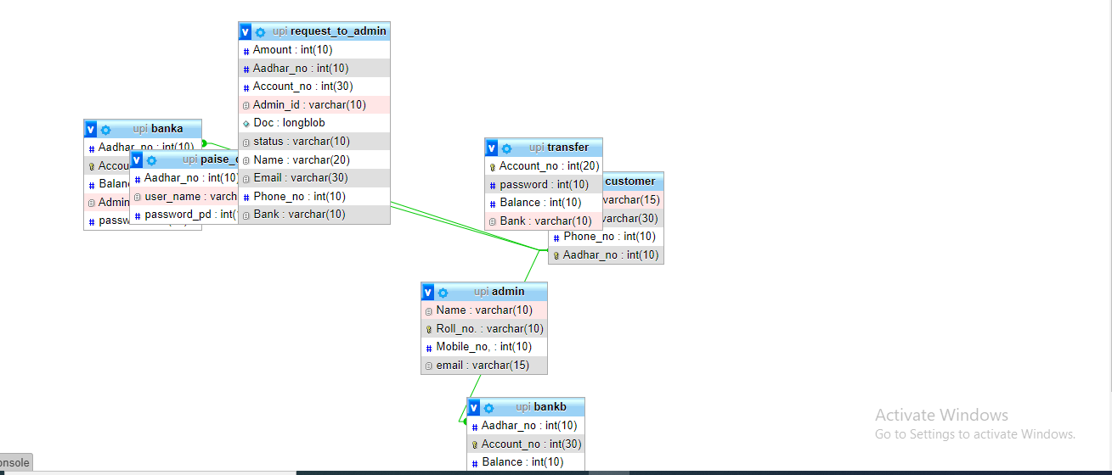

7. PROJECT SCREENSHOTS

1.INDEX PAGE

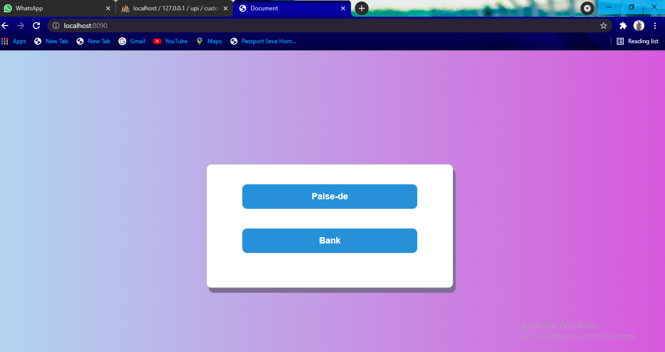

2.CREATE ACCOUNT & ADD BALANCE & ADMIN PAGE

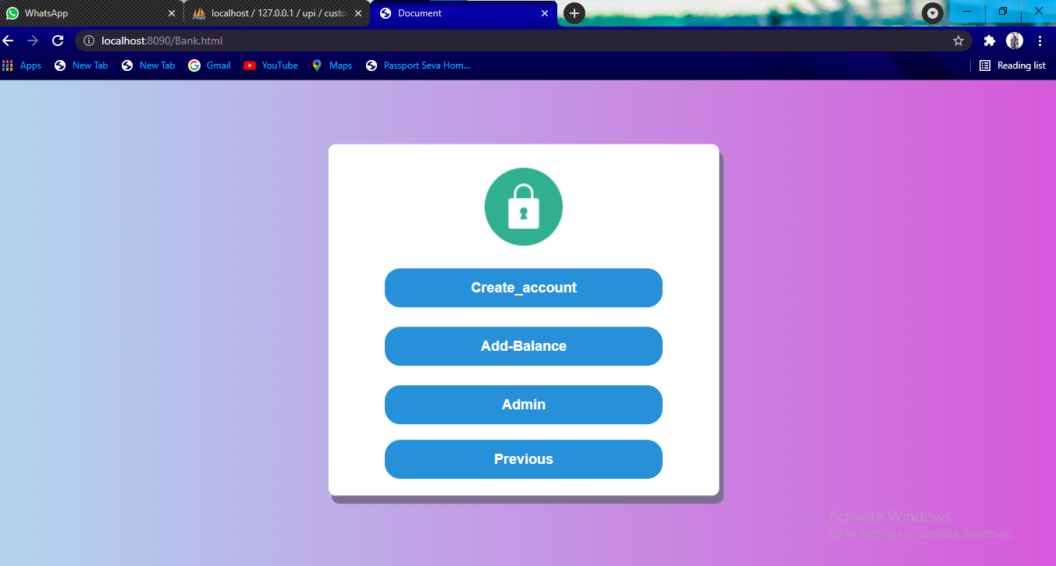

3.LOGIN PAGE



4. ACCOUNT ADDING PAGE

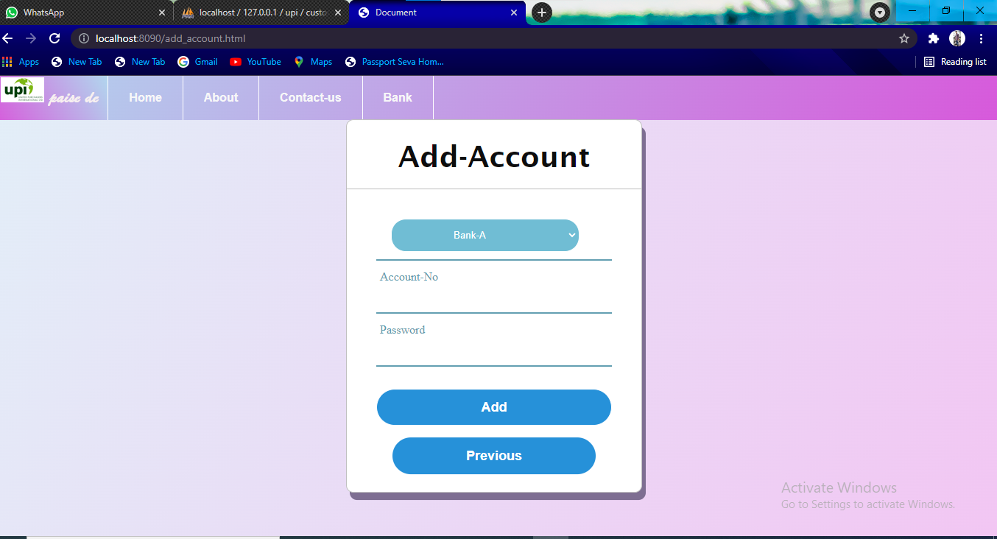

5. AMMOUNT TRANSFER PAGE

